Sealed Class

Sealed class is used to define the inheritance level of a class.

The sealed modifier is used to prevent derivation from a class. An error occurs if a sealed class is specified as the base class of another class.

1. A class, which restricts inheritance for security reason is declared sealed class.
2. Sealed class is the last class in the hierarchy.
3. Sealed class can be a derived class but can't be a base class.
4. A sealed class cannot also be an abstract class. Because abstract class has to provide functionality and here we are restricting it to inherit.

Example

Sealed class with out error.

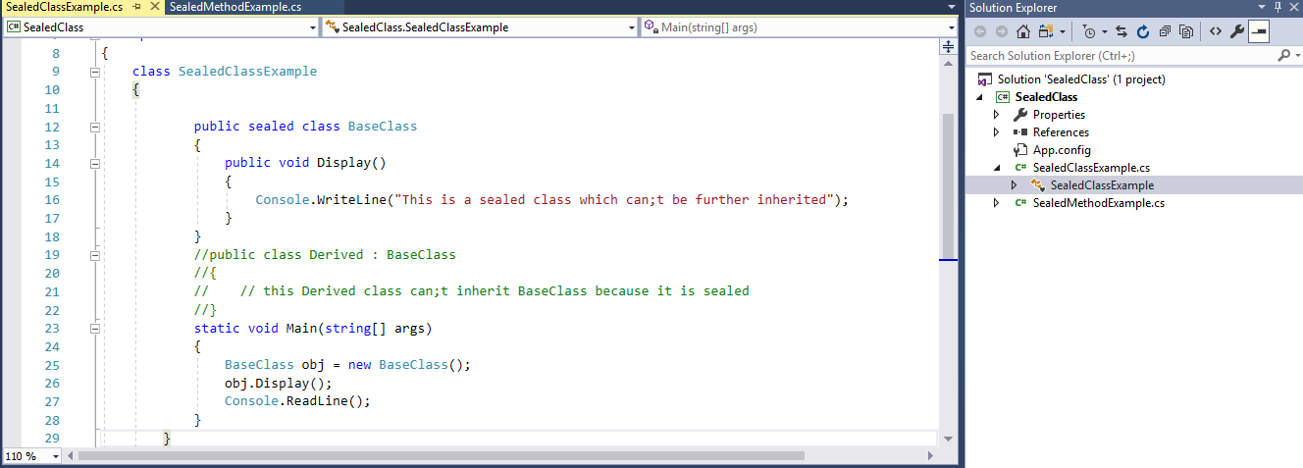

Sealed class with error

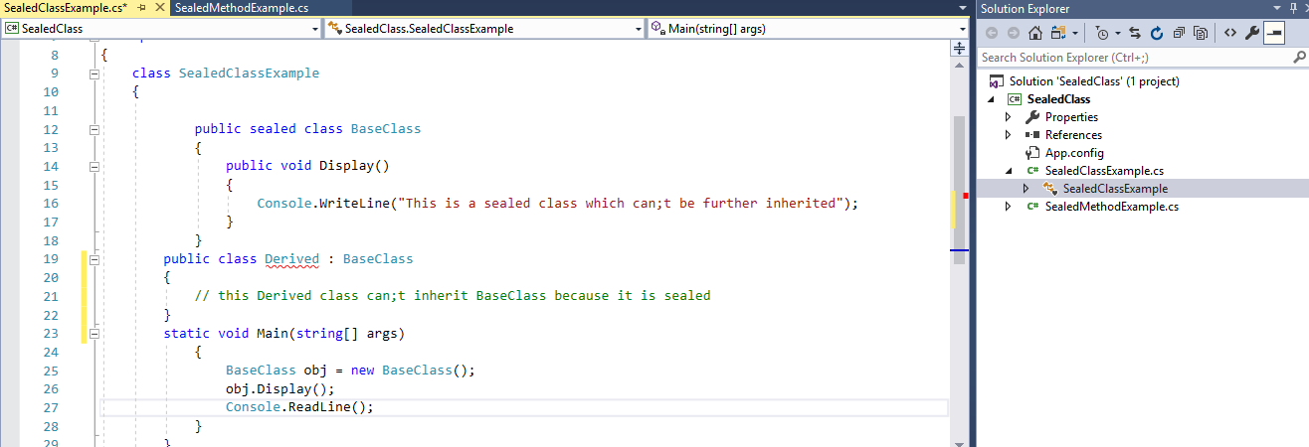

Error display

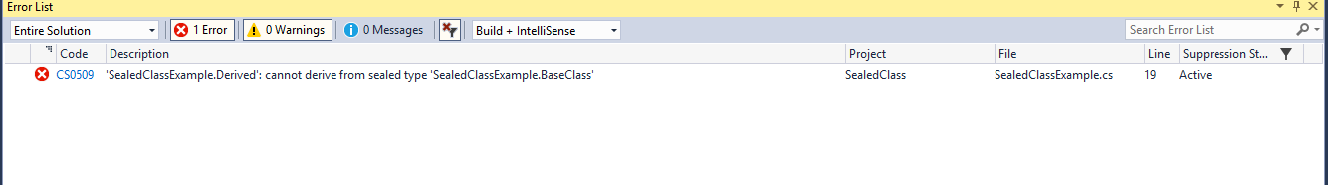

## Sealed Methods

Sealed method is used to define the overriding level of a virtual method.

Sealed keyword is always used with override keyword.

Practical demonstration of sealed method

example

Sealed methods with out error

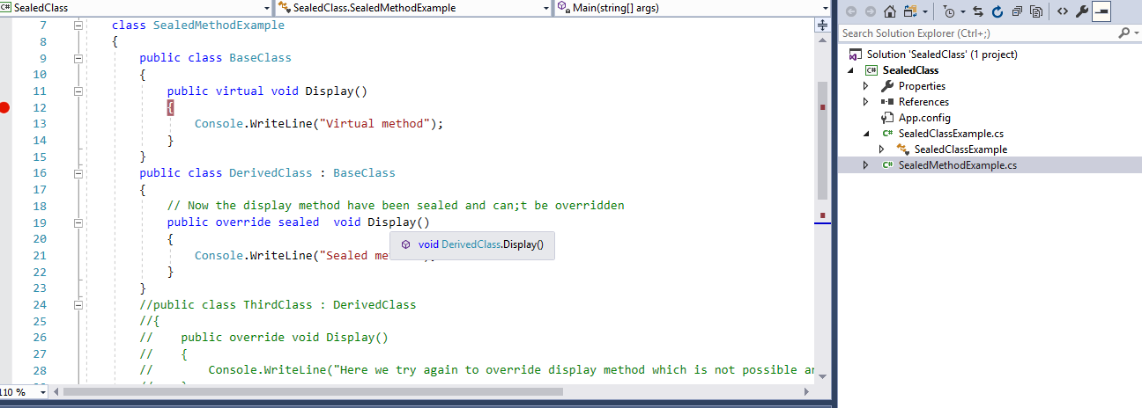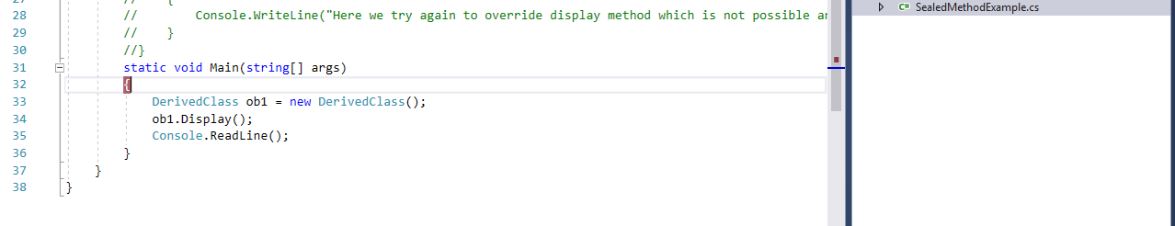

Sealed method with error

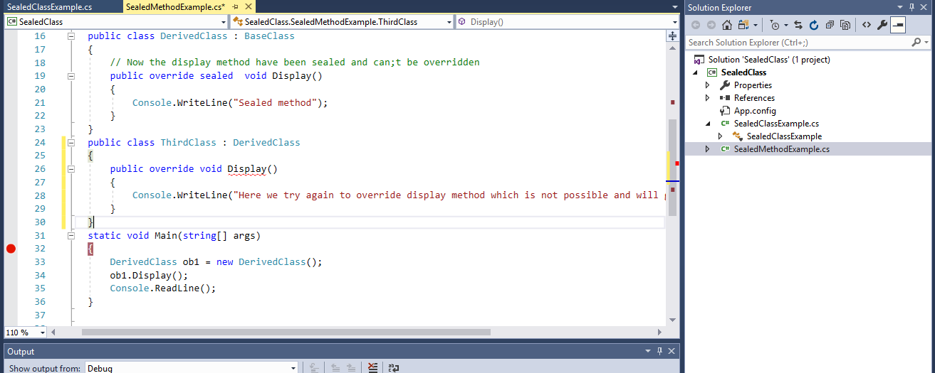

Error message

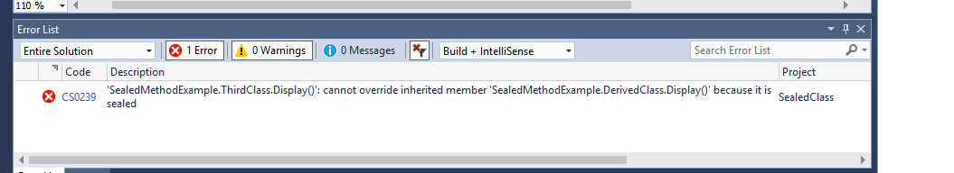

**Why Sealed Classes?**

* Sealed class is used to stop a class to be inherited. You cannot derive or extend any class from it.
* Sealed method is implemented so that no other class can overthrow it and implement its own method.
* The main purpose of the sealed class is to withdraw the inheritance attribute from the user so that they can’t attain a class from a sealed class. Sealed classes are used best when you have a class with static members.  
  *example*  the “Pens” and “Brushes” classes of the System. Drawing namespace. The Pens class represents the pens for standard colours. This class has only static members. For example, “Pens. Red” represents a pen with red colour. Similarly, the “Brushes” class represents standard brushes. “Brushes. Red” represents a brush with red colour.